**A PROJECT REPORT**

**ON**

**“A STUDY ON FINANCIAL POSITION OF COAL INDIA LIMITED”**

**SUBMITTED TO**



**RANIGANJ INSTITUTE OF COMPUTER AND INFORMATION SCIENCES**

**BY SHREYA MUKHERJEE**

**BBA (H) FINANCE**

**ACADEMIC YEAR 2021-2024**

**Kazi Nazrul University (KNU)**

*Under The Guidance of -*

Mr. SK. Sadique (Project Guide) Mr. Surajit Bhattacharya

Finance Manager Asst. Professor

Eastern Coal Field Limited RICIS

(West Bengal)

**GUIDE CERTIFICATE**

This is to certify that the project report entitled.

……………………………………………………………………………………

……………………………………………………………………………………

……………………………………………………………………………………

……………………………………………………………………………………

Submitted in partial fulfillment of the requirement for the degree of Bachelor of Business Administration to Raniganj Institute of Computer and Informational Science (RICIS), Kazi Nazrul University.

Name ……………………………………of 2021-2024 has worked under my supervision and guidance and no part of this report has been submitted for the award of any other degree or diploma.

Certified

Guide’s Signature

**ACKNOWLEDGEMENT**

I take this opportunity to express my sincere thanks to the management and staff of **EASTERN COALFIELD LIMITED** for providing me with those valuable learning opportunities.

I am grateful to *Mr. Surajit Bhattacharya* for their help. Special thanks to the Area Manager, *Mr. SK. Sadique*, and all others for their sincere involvement and support.

My deepest thanks to the whole ECL staff, with whom I learned and gained from every second of my interaction.

I am forever grateful to *Mr. Surajit Bhattacharya*, my project guide, who helped make a Herculean finish simple. Without his resourceful leadership, this project would not have been finished.

**DECLARATION**

I certify that the project work named "**A STUDY ON FINANCIAL POSITION OF COAL INDIA LIMITED**" submitted by me to RANIGANJ INSTITUTE OF COMPUTER INFORMATION SCIENCES for full fulfillment of BBA (H) Finance is a genuine project work completed under the supervision of ***Mr. Surajit Bhattacharya.***

To my understanding, the information provided is accurate and practical.

Shreya Mukherjee

BBA(H) FINANCE

|  |  |  |
| --- | --- | --- |
| **SR NO.** | **CONTENT** | **PAGE** |
| **1.** | CERTIFICATE FROM PROJECT GUIDE(S) | 4 |
| **2.** | INTRODUCTION | 7 |
| **3.** | OBJECTIVE OF THE STUDY | 8 |
| **4.** | OVERVIEW | 9-11 |
| **5.** | HISTORY | 12-13 |
| **6.** | GEOGRAPHIC LOCATION & AREA | 14 |
| **7.** | MINES & MANPOWER & COAL RESERVE | 15 |
| **8.** | CIL Coal Production | 16-17 |
| **9.** | Board of Directors | 18-19 |
| **10.** | Organizational Structure | 20 |
| **11.** | Subsidiary Companies under Coal India LTD | 21 |
| **12.** | CIL Achievement | 22 |
| **13.** | Research Methodology | 23-25 |
|  | Sample plan |  |
|  | Sample Size |  |
|  | Time frame of the study |  |
|  | Sources of Data |  |
|  | Primary Data |  |
|  | Secondary Data |  |
| **14.** | Sampling Procedure | 25 |
|  | Convenience sampling |  |
| **15.** | Techniques or Tools for Data Analysis | 26 |
| **16.** | Accounting ratios | 27-29 |
|  | Ratios and Its measurement |  |
|  | Liquidity Ratios |  |
|  | Profitability Ratios |  |
|  | Debt Ratios |  |
| **17.** | Current Ratio Table | 30 |
| **18.** | Quick Ratio Table | 31 |
| **19.** | Gross Profit Ratio | 32-33 |
| **20.** | Return On Assets | 34 |
| **21.** | Debt-to-Equity Ratio | 35 |
| **22.** | Debt Ratio | 36-37 |
| **23.** | Conclusion | 38 |
| **24.** | Recommendations and Suggestions | 39 |
| **25.** | ANNEXURE | 40 |

**CERTIFICATE FROM PROJECT GUIDE(S)**

This is to certify that the project entitled “**A Study on Financial Position of Coal India Limited.**” submitted by: - Shreya Mukherjee for the award of a BBA (FINANCE) degree from *“Kazi Nazrul University (KNU)* ” is based upon his work under the supervision of Prof. Surajit Bhattacharya, Department of Finance management, Raniganj Institute Of Computer and Information Sciences, Raniganj, West Bengal, India and that neither her project report nor any part of the report has been submitted for any degree/diploma or any other academic award anywhere before.

**Introduction**

Coal India Limited (CIL) the state-owned coal mining corporation came into being in November 1975. With a modest production of 79 Million Tonnes (MTs) at the year of its inception CIL today is the single largest coal producer in the world and one of the largest corporate employers with a manpower of 272445 (as of 1st April 2020). CIL functions through its subsidiaries in 84 mining areas spread over eight (8) states of India. Coal India Limited has 352 mines (as of 1st April 2020) of which 158 are underground, 174 are opencast and 20 are mixed mines. CIL further operates 12 coal washeries, (10 coking coal and 2 non-coking coal) and also manages other establishments like workshops, hospitals, and so on. CIL has 26 training Institutes and 84 Vocational Training Centres. Indian Institute of Coal Management (IICM) as a state-of-the-art Management Training ‘Centre of Excellence’ – the largest Corporate Training Institute in India - operates under CIL and conducts multi-disciplinary programs.

CIL is a *Maharatna* company - a privileged status conferred by the Government of India to select state-owned enterprises in order to empower them to expand their operations and emerge as global giants. The select club has only ten members out of more than three hundred Central Public Sector Enterprises in the country.

CIL has seven producing subsidiaries namely Eastern Coalfields Limited (ECL), Bharat Coking Coal Limited (BCCL), Central Coalfields Limited (CCL), Western Coalfields Limited (WCL), South Eastern Coalfields Limited (SECL), Northern Coalfields Limited (NCL)and Mahanadi Coalfields Limited (MCL) and One mine planning and consultancy company that is Central Mine Planning & Design Institute (CMPDI). In addition, CIL has a foreign subsidiary in Mozambique namely Coal India Africana Limitada (CIAL). The mines in Assam i.e. North Eastern Coalfields are managed directly by CIL.

**Objective of the study**

* To measure and evaluate the liquidity position of CIL.
* To determine the profitability condition of the selected unit in the study.
* To provide recommendations and suggestions based on the above study

**overview**

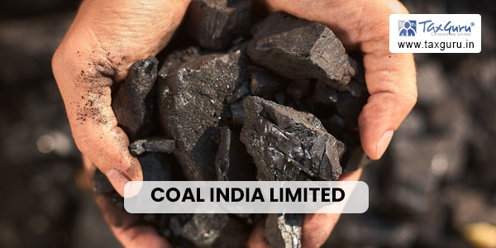Coal India Limited (CIL) the state-owned coal mining corporate came into being in November 1975. With a modest production of 79 Million Tonnes (MTs) at the year of its inception CIL today is the single largest coal producer in the world and one of the largest corporate employers with a manpower of 272445 (as of 1st April 2020). CIL functions through its subsidiaries in 84 mining areas spread over eight (8) states of India. Coal India Limited has 352 mines (as of 1st April 2020) of which 158 are underground, 174 opencast, and 20 mixed mines. CIL further operates 12 coal washeries, (10 coking coal and 2 non-coking coal) and also manages other establishments like workshops, hospitals, and so on. CIL has 26 training Institutes and 84 Vocational Training Centres. Indian Institute of Coal Management (IICM) as a state-of-the-art Management Training ‘Centre of Excellence’ – the largest Corporate Training Institute in India - operates under CIL and conducts multi-disciplinary programs.

CIL is a Maharatna company - a privileged status conferred by the Government of India to select state-owned enterprises to empower them to expand their operations and emerge as global giants. The select club has only ten members out of over three hundred Central Public Sector Enterprises in the country.

CIL has seven producing subsidiaries namely Eastern Coalfields Limited (ECL), Bharat Coking Coal Limited (BCCL), Central Coalfields Limited (CCL), Western Coalfields Limited (WCL), South Eastern Coalfields Limited (SECL), Northern Coalfields Limited (NCL)and Mahanadi Coalfields Limited (MCL) and One mine planning and consultancy company that is Central Mine Planning & Design Institute (CMPDI). In addition, CIL has a foreign subsidiary in Mozambique namely Coal India Africana Limitada (CIAL). The mines in Assam i.e. North Eastern Coalfields are managed directly by CIL.

Mahanadi Coalfields Limited has four (4) subsidiaries which are i) MJSJ Coal Limited ii) MNH Shakti Ltd, iii) Mahanadi Basin Power Ltd iv) Neelanchal Power Transmission Company Private Ltd

SECL has two subsidiaries i) M/s Chhattisgarh East Railway Ltd (CERL) and ii) M/s Chhattisgarh East- West Railway Ltd (CEWRL)

CCL has one subsidiary – Jharkhand Central Railway Ltd

The Psu contributes around 82% to the total coal production in India. It produced 554.14 million tonnes of raw coal in 2016–17, an increase from its earlier production of 494.24 million tonnes of coal during fy 2014–15, and earned revenues of ₹95,435 crores (us$12 billion) from the sale of coal in the same financial year in April 2011, CIL was conferred the maharatna status by the government of India, making it one of the seven with that status as of 14 October 2015, cil is a psu owned by the central government of India which controls its operations through the ministry of coal. as of 14 October 2015, CIL's market capitalization stood at ₹2.11 lakh crore (us$26 billion) making it India's 8th most valuable company.

Cil ranks 8th among the top 20 firms responsible for a third of all global carbon emissions.

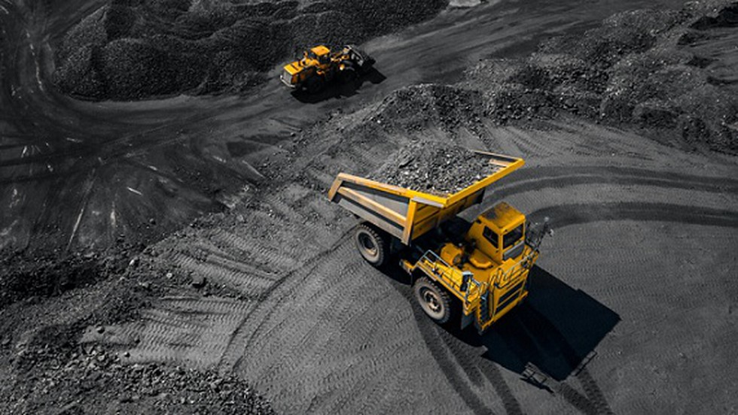

**Unmatched Strategic Relevance**

Produces around 83% of India’s overall coal production in India where approximately 57% of primary commercial energy is coal-dependent, CIL alone meets to the tune of 40% of primary commercial energy requirements. The share of coal is expected to remain high at 48-54% till 2040 and accounts for 76% of the total thermal power generating capacity of the Utility sector. Supplies coal at prices discounted to international prices and insulates Indian coal consumers against price volatility. Makes the end-user industry globally competitive and plays a key role in “Make in India” making India globally competitive.

**Production and Growth**

During 2019-20, CIL produced 602.138 Million Tonnes (MTs) of coal under challenging and adverse conditions achieving 91% of its target. CIL has breached the 600 Million Tonne (MT) mark in coal production for the second time. On 30 March 2020, CIL set a new record by producing 3.86 Mts, the highest-ever production in a day since its foundation. Northern Coalfields Limited and Western Coalfields Limited exceeded their respective annual production targets for 2019-20, achieving 102% and 103% of their respective targets. While NCL produced 108.05 MTs for the fiscal, WCL’s was 57.64 Mts. Raw coal off-take for the Financial Year ending 31st March 2020 was 581.411 MT and Over Burden Removal (OBR) was 1154.33 M Cum. The despatch of coal and coal products during 2019-20 was at 582.48 Mts and the despatch to power utilities (including special forward e-Auction) was 465.72 MTs. Overall coal stock at powerhouses was its highest in a decade at 45 .01 Mts (28 days) as of 31.3.2020.

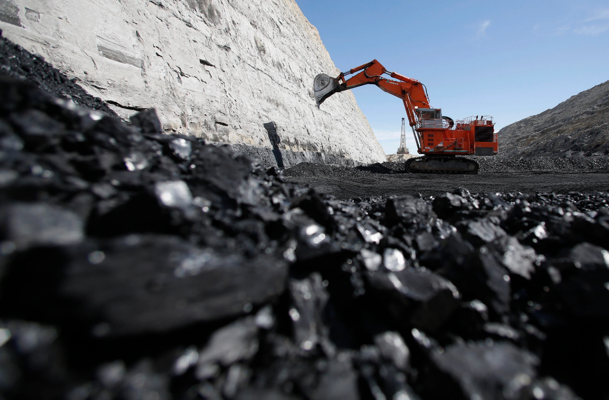

**History**

Coal mining in India had primarily been a private-sector enterprise. This changed in September 1956 when the Government of India established its own coal company National Coal Development Corporation (NCDC). Collieries run by the Railways formed the nucleus of NCDC. This was to fulfill the fast-growing energy requirements in the country to support rapid industrialization taking place through the Five-Year Plans of the Government. In the same year, Singareni Colliery Company, which had been operating in Andhra Pradesh since 1920, was also brought under Government control when the Central Government and State Government of Andhra Pradesh acquired 45% and 55% shares respectively.

In 1971, the Government of India nationalized all the 214 coking-coal mines and 12 coke ovens running in the private sector, excluding those held by TISCO and IISCO for their captive use. On 1 January 1972, a new Government company Bharat Coking Coal Limited (BCCL) was formed to take control of these nationalized mines and coke ovens. On 30 January 1973, all the remaining 711 non-coking coal mines of the country in the private sector were also nationalized. 184 of these mines were handed over to BCCL, and the remaining 527 were handed over to a newly opened department Coal Mines Authority. 4 months later, on 14 June 1973, this department was converted into a separate Government company CMAL. NCDC, earlier formed in 1957, was merged with CMAL, and 45% share-holding of the Central Government in Singareni Collieries Company Ltd was also handed over to CMAL. CMAL started functioning with its 4 divisions, viz, Eastern Coalfields, Central Coalfields, Western Coalfields, and Central Mine Planning and Design Institute.

By 1973, all coking coalmines were under BCCL, which was functioning as a subsidiary of the Steel Authority of India (SAIL) under the Department of Steel of the Ministry of Steel and Mines; and all non-coking coalmines were under CMAL, which was under the Department of Mines of the Ministry of Steel and Mines. For better control, both BCCL and CMAL were brought on 11 October 1974 under the Department of Coal (now an independent Ministry) of the newly formed Ministry of Energy.

On 1 November 1975, a new public-sector company Coal India Limited (CIL) was formed to enable better organizational and operational efficiency in the coal sector. All 4 Divisions of CMAL were given the company status and were brought under CIL along with BCCL. 45% share-holding of the CMAL in Singareni Collieries Company was also transferred to CIL, and CMAL was closed.

Thus, CIL started functioning in 1975 with 5 subsidiary companies under it. These were Bharat Coking Coal Limited (BCCL), Eastern Coalfields Limited (ECL), Central Coalfields Limited (CCL), Western Coalfields Limited (WCL), and Central Mine Planning & Design Institute Limited (CMPDIL). In due course of time, 3 more companies were formed under CIL by carving out certain areas of CCL and WCL. These were Northern Coalfields Limited (NCL), South-Eastern Coalfields Limited (SECL), and Mahanadi Coalfields Limited (MCL).

According to the Fuel Policy of 1974, CIL also started the construction of India's First Low-Temperature Carbonisation Plant at Dankuni in the late 1970s. It was renamed as Dankuni Coal Complex and is one of the only operational Coal gas plants of this kind in the world.[22] Dankuni Coal Complex has been incurring heavy losses due to the Greater Calcutta Gas Supply Company (formerly known as Oriental Gas Co.) giving non-remunerative prices and fixing them unilaterally. Coal India is planning to venture into Coal-to-Methanol technology at the existing Plant.

The Government of India held 100% equity in CIL from 1975 till 2010.

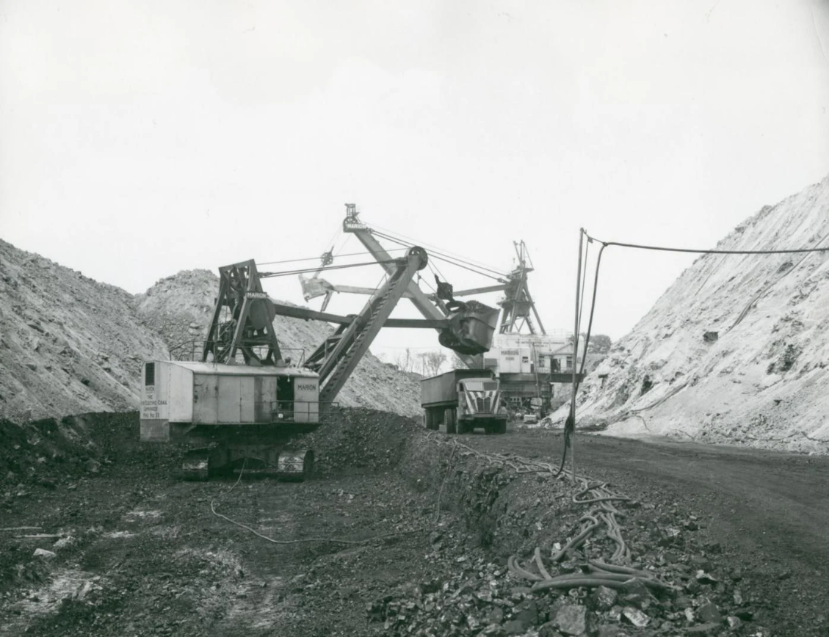

**GEOGRAPHIC LOCATION & AREA**

Coal India Limited (CIL) is an Indian central public sector undertaking under the ownership of the Ministry of Coal, Government of India. It is headquartered in Kolkata. It is the largest government-owned-coal-producer in the world. It is also the ninth largest employer in India with nearly 272,000 employees.

Coal India operates through 83 mining areas in 8 states of India. As of 1 April 2015, it has 430 coal mines out of which 175 are open cast, 227 are underground and 28 are mixed mines. Production from open-cast mines during FY 2014–15 was 92.91% of total production of 494.24 MT.

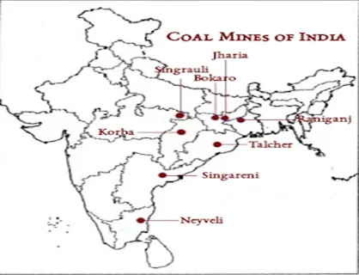

**MINES & MANPOWER:**

CIL functions through its subsidiaries in **84** mining areas spread over eight (**8**) states of India. Coal India Limited has **352** mines (as of **1st April 2020**) of which **158** are underground, **174** are opencast and **20** are mixed mines.

The existing manpower in Coal India had over **239,000** employees during the financial year **2023**.

**COAL RESERVE:**

During the Calendar Year **2022-23**was **893.19 MT** with a positive growth of **14.77%.**

Coal India Limited (CIL) and its subsidiaries accounted for **622.63** **MT** during **2021-22** compared to the production of **596.22** **MT** in **2020-21** showing a positive growth of **4.4%.** Coal production of CIL during **2022-23** was **703.20 MT** with a positive growth of **12.94%.**

**CIL Coal Production**

Coal India Limited, scripting a prolific performance, has ended FY 2022-23 with record-high coal production of 703.20 million tonnes (MTs) and coal off-take of 694.70 MTs. Concurrently, overburden removal soared to 1656.85 million cubic meters (M.CuM) which is yet another high so far.

**Coal Production**

1. CIL produces non-coking coal and coking coal of various grades for diverse applications. The following table provides certain information relating to the non-coking coal and coking coal produced by us in the periods indicated:

|  |  |  |  |  |
| --- | --- | --- | --- | --- |
| Grades |  | **Non-Coking Coal** | **Coking Coal** | **Total** |
| **2018-19** | Raw Coal Production Mill Te | 572.75 | 34.14 | 606.89 |
| **2018-19** | % of Total Raw Coal Production | 94.4 | 5.6 | 100.0 |
| **2019-20** | Raw Coal Production Mill Te | 555.70 | 46.44 | 602.14 |
| **2019-20** | % of Total Raw Coal Production | 92.3 | 7.7 | 100.0 |
| **2020-21** | Raw Coal Production Mill Te | 557.38 | 38.84 | 596.22 |
| **2020-21** | % of Total Raw Coal Production | 93.5 | 6.5 | 100.0 |
| **2021-22** | Raw Coal Production Mill Te | 576.03 | 46.60 | 622.63 |
| **2021-22** | % of Total Raw Coal Production | 92.5 | 7.5 | 100.0 |
| **2022-23** | Raw Coal Production Mill Te | 648.58 | 54.63 | 703.20 |
| **2022-23** | % of Total Raw Coal Production | 92.2 | 7.8 | 100.0 |

1. **COMPANY-WISE DETAILS 2022-23**

|  |  |  |  |  |
| --- | --- | --- | --- | --- |
| **DETAILS** | **UG** | **OC** | **TOTAL** | **OFFTAKE** |
| **UNIT** | Mill Te | Mill Te | Mill Te | Mill Te |
| **ECL** | 8.97 | 26.05 | 35.02 | 35.49 |
| **BCCL** | 0.69 | 35.49 | 36.18 | 35.57 |
| **CCL** | 0.86 | 75.23 | 76.09 | 75.03 |
| **NCL** | 0.00 | 131.17 | 131.17 | 133.51 |
| **WCL** | 2.89 | 61.40 | 64.28 | 62.16 |
| **SECL** | 11.64 | 155.36 | 167.01 | 160.05 |
| **MCL** | 0.44 | 192.82 | 193.26 | 192.72 |
| **NEC** | 0.00 | 0.20 | 0.20 | 0.18 |
| **CIL** | 25.49 | 677.72 | 703.20 | 694.70 |

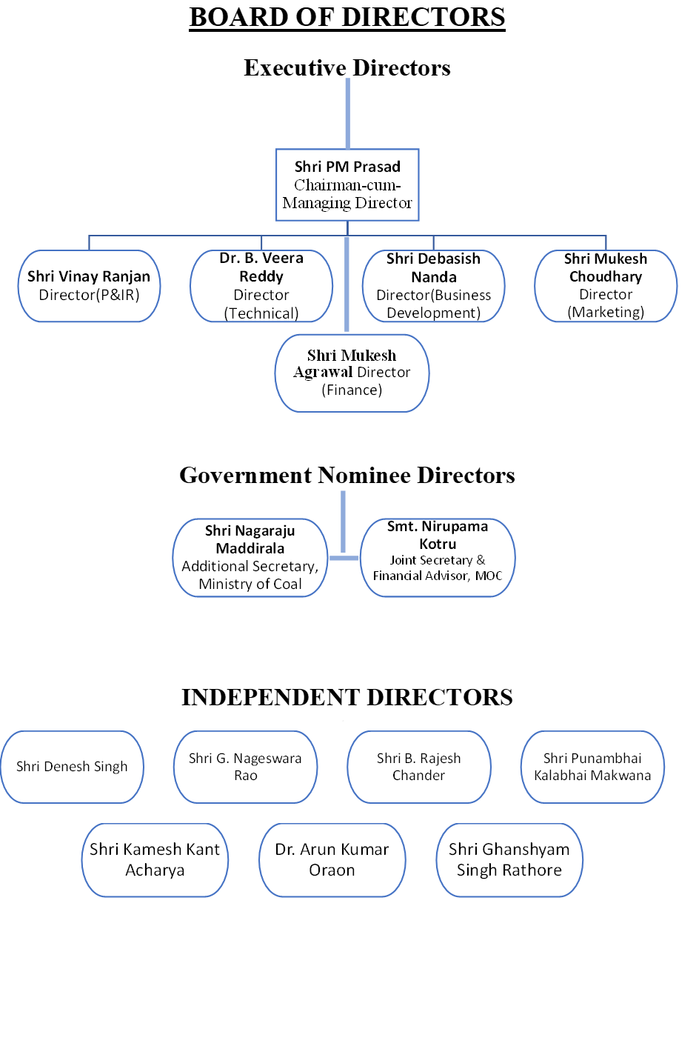

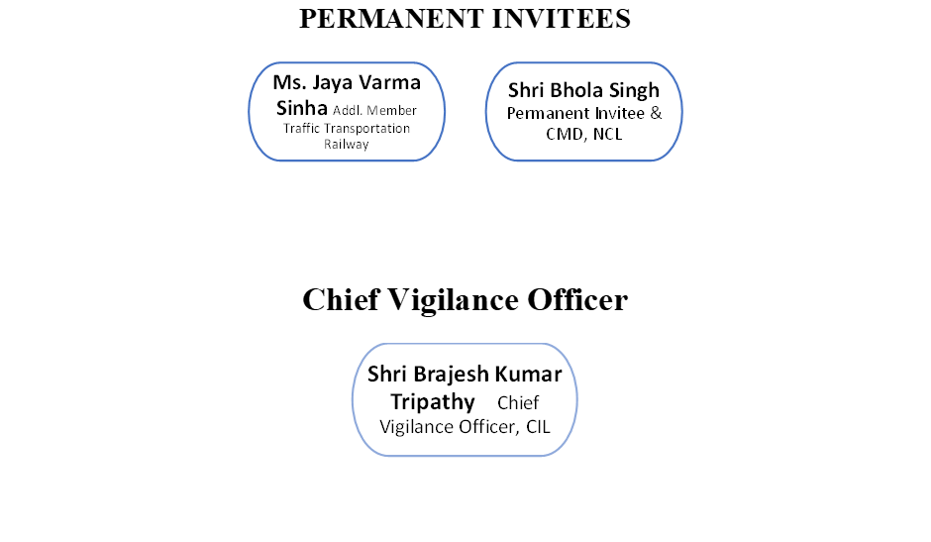

**Organizational Structure**

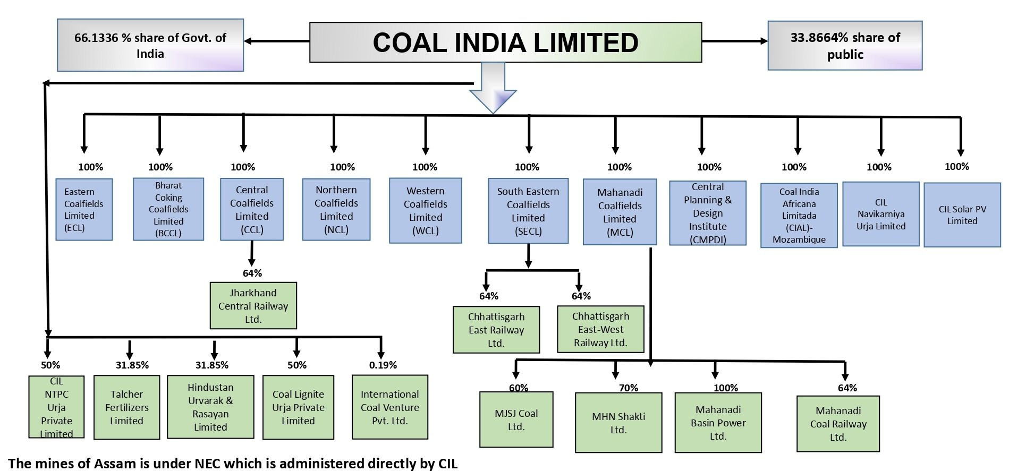

**Subsidiary Companies under Coal India LTD**

|  |  |
| --- | --- |
| ⮊ Bharat Coking Coal Limited | Koyla Bhawan, Dhanbad, Jharkhand, India |
| ⮊ Central Coalfields Limited | Darbhanga House, Cutchery Road, Ranchi - 834001**,** Jharkhand |
| ⮊ Central Mine, Planning & Desing Institute Limited | Gondwana Place, Kanke Road, Ranchi, Jharkhand, India |
| ⮊ Eastern Coalfields Limited | Sanctoria, Dishergarh, WB-713333, India |
| ⮊ Mahanadi Coalfields Limited | Jagritibihar, Sambalpur, Orissa, India PIN: 768020 |
| ⮊ Northern Coalfields Limited | Singarauli, Sidhi, MP |
| ⮊ South Eastern Coalfields Limited | Seepat Road, Bilaspur, Chhattisgarh |
| ⮊ Western Coalfields Limited | Civil Lines, Nagpur, Maharastra |

**CIL Achievement**

Coal India Limited (CIL) has made several notable achievements in recent years. Here are some highlights:

**Production Milestones:** CIL surpassed its previous year’s coal production by reaching 703.91 million tonnes up to March 7, 2024, which was a significant increase from the previous year’s total of 703.20 MT1.

**Awards and Recognition:** CIL was awarded for its ‘Strategic Performance’ in the Maharatna Category at the Governance Now 7th PSU Awards2. Additionally, CIL’s Chairman was honored with the prestigious Bhaskar Bhattacharjee Memorial Award by IIT (ISM), Dhanbad3.

**CSR Initiatives:** CIL was felicitated by the Ministry of Health & Family Welfare for being the first PSU to utilize its CSR funds to help underprivileged children access Bone Marrow Transplant (BMT) under the 'Thalassemia Bal Seva Yojana’2.

**Innovation in Procurement:** CIL received an award for its automated e-tendering system for excellence in ‘Innovation in Procurement Process’ by the Indian Institute of Materials Management2.

**Record Production Days:** On March 30, 2020, CIL set a new record by producing 3.86 million tonnes, the highest ever production in a single day since its foundation4.

**Coal Gasification Projects:** The Ministry of Coal highlighted successful auctions of coal mines and the signing of crucial MoUs for Coal Gasification projects as major achievements

These achievements reflect CIL’s commitment to enhancing production efficiency, corporate social responsibility, and strategic performance in the energy sector.

**RESEARCH METHODOLOGY**

The research study was carried out using observational methods for gathering data. The annual report available on the CIL website contains data that comes from audit financial statements (i.e., balance sheet and profit and loss).

The analysis of the data was done through simple accounting ratios such as gross profit ratio, net profit, operating profit, net sales, current assets to current liabilities, office expenses, depreciation, net sales, cost of goods, turnover ratio in days, and inventory turnover ratio in days.

**Sample plan:**

A sample design is a specific plan to carry out an overall examination of a certain population. It refers to the strategy or approach that the researcher will use to choose things for use in the sample. The researcher should choose a design that is reliable and suitable for the study.

**Sample Size:**

The current project picked CIL as a model unit to achieve the project's objectives among Coal India Limited subsidiaries. Due to limited resources and time, just one sample unit was chosen for the investigation.

**Time frame of the study**

The necessary financial data are collected throughout the years, starting in 2018-2019 and ending in 2022-2023. The sample unit's financial year runs from April 1st to March 31st of each year.

**Sources of Data:**

Data collecting is an ongoing process in marketing research. The design of the data collecting technique is the foundation of the research design. Data sources are divided into two types.

* The Primary Data.
* The Secondary Data.

**Primary Data:**

Primary data are fresh data created directly from the field, and so provide original information gathered for a specific purpose. It is costly, difficult, and time-consuming. However, because information comes directly from the source, it is more accurate and reliable.

**Secondary Data:**

Secondary data are data that the investigator collects from others who have gathered it for a variety of objectives. As a result, it may not be completely dependable. It costs less, takes less time, and requires less effort than collecting original data.

This project solely collected secondary data, which served as the foundation for the entire research. Secondary data in the form of financial annual reports available on the CIL website was acquired for data analysis. Secondary data, such as the company's profit and loss statement and balance sheet, were acquired for the study.

**Sampling Procedure:**

For a statistical survey of a population, the investigator may gather information from all units within the population or simply a few sample units. The term sample refers to a collection of representative units from whom information is taken. A sample is a representative subset of the population. A sample survey refers to a statistical survey that uses a sample. The process of taking a sample from a population is known as a sampling technique. Because the validity of survey results is mostly determined by sample selection, the sample should be acquired with extreme caution. Important methods of sampling procedure are:

1. Random sampling.
2. Judgment sampling.
3. Quota sampling.
4. Convenience sampling

**Convenience sampling**:

Convenience sampling is a non-probability sampling method where data is collected from an easily accessible and available group of people. The individuals in the sample are selected not because they are most representative of the entire population, but because they are most easily accessible to the researcher.

In this study, we chose the convenience sampling approach since it is easy to gather the necessary data for analysis.

**Technique Or Tools for Data Analysis:**

Accountants use data analytics to gain insights from financial data using a variety of methodologies and technologies. Here are several important aspects:

**Techniques:**   
1. Descriptive Analytics: Examines past financial activity.

2. Diagnostic Analytics: Investigates why certain events happened.

3. Predictive Analytics: Forecasts future financial conditions using historical data.

4. Prescriptive Analytics: Suggests actions to achieve desired outcomes in financial operations.

**Tools:**   
**1. Excel** is a popular tool for basic data analysis and visualization.

**2. Business Intelligence technologies:** These technologies enable complicated data analysis and provide actionable insights.

**3. Proprietary Tools:** Tools created by firms to meet their own accounting analytics needs.

**4. R and Python** are programming languages that enable advanced statistical analysis and modeling.

These strategies and technologies are critical for accountants to manage risks, find process improvements, and assist with strategic decision-making. They have altered the accounting industry, boosting efficiency and competitiveness in the market.

**Accounting ratios**:

Accounting ratios are key financial metrics that help analyze a company’s financial health and performance. They compare different figures from the financial statements, such as the balance sheet and income statement, to provide insights into aspects like profitability, liquidity, and solvency.

Here are some common types of accounting ratios and their formulas:

**Ratios and Its measurement:**

Accounting ratios and their measurements are essential for evaluating a company’s financial health. They provide a quantitative analysis of a company’s efficiency, profitability, and solvency by comparing different financial statement figures. Here’s a brief overview of some key accounting ratios and their measurements:

**Liquidity Ratios:**

* **Current Ratio:** Measures a company’s ability to pay short-term obligations with its current assets. The formula is:

​

In March 2024 Current Ratio was 7.59 and in March 2023 Current Ratio was 5.08

* **Quick Ratio:** Also known as the acid-test ratio, it measures immediate liquidity excluding inventory. The formula is:

In March 2024 Quick Ratio was 7.52 and In March 2023 Quick Ratio was 5.05

**Profitability Ratios:**

* 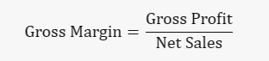**Gross Margin:** Indicates the percentage of revenue that exceeds the cost of goods sold. The formula is:

In March 2024 PBIT Margin (%) 1,060.91 In Mar 2021 PBIT Margin (%) is 1.201.91

* 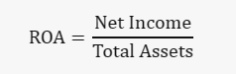**Return on Assets (ROA):** Shows how efficiently a company uses its assets to generate profit. The formula is:

The ROA Ratio of COALINDIA rose handsomely by 38.08 % this year. ROA Ratio with a value of 13.32 was the highest in Year Mar-23 in the Last Five Years. ROA Ratio with the value of 7.85 was the lowest in Year Mar-21 in the Last Five Years. The latest ROA Ratio with the value of 13.32 is Greater than the Average ROA of 11.02 in the last five years.

**Debt Ratios:**

* 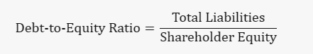**Debt-to-Equity Ratio:** Compares a company’s total liabilities to its shareholder equity to assess financial leverage. The formula is:

​

The latest Total Debt/Equity ratio of COAL INDIA is 0.07 based on Mar2023 Consolidated results.

* 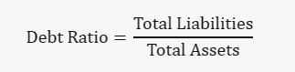**Debt Ratio:** Measures the proportion of a company’s assets financed through debt. The formula is:

Coal India has a total shareholder equity of ₹835.8B and a total debt of ₹62.9B, which brings its debt-to-equity ratio to 7.5%

**Current Ratio Coal India Limited**

|  |  |
| --- | --- |
| **Year** | **Current Ratio** |
| **2018-2019** | 3.28% |
| **2019-2020** | 4.72% |
| **2020-2021** | 3.22% |
| **2021-2022** | 2.77% |
| **2022-2023** | 1.17% |

**Interpretation: -**

The current ratio, which looks at a company's capacity to fulfill short-term obligations using current assets, is an important sign of financial health. Coal India Ltd (CIL)'s current ratio has been falling during the last five years.

**2019:** The current ratio was 3.28%, suggesting a strong liquidity position with current assets greatly far exceeding current liabilities.

**2020:** A rise to 4.72% indicates even greater liquidity and perhaps prudent asset management.

**2021:** A small decrease to 3.22% may be due to improvements in working capital management or changes in short-term liabilities.

**2022:** The ratio fell further to 2.77%, indicating a deliberate move forward with more efficient asset use or a rise in short-term liabilities.

**2023:** A difficult decrease to 1.17% raises questions about the company's liquidity as it approaches the point when current assets are virtually equal to current liabilities.

This declining trend might be the result of many different kinds of causes, including increasing investment in long-term projects, changes in market conditions, or an intelligent decision to use more short-term finance. It is critical to analyze these data in light of industry standards and the company's operational strategy.

**Quick Ratio of Coal India Limited**

|  |  |
| --- | --- |
| **Year** | **Quick Ratio** |
| **2018-2019** | 3.05% |
| **2019-2020** | 4.70% |
| **2020-2021** | 3.14% |
| **2021-2022** | 2.72% |
| **2022-2023** | 1.62% |

**Interpretation: -**

The quick ratio measures a company's ability to satisfy short-term obligations using its most liquid assets. The quick ratio for Coal India Ltd (CIL) shows a declining tendency during the five years from 2014 to 2018. This may be examined as follows:

**2019:** CIL's quick ratio was 3.05%, showing that it had enough liquid assets to pay its current liabilities and was in good financial health.

**2020:** The ratio improved to 4.70%, indicating an improvement in the company's liquidity and capacity to satisfy short-term obligations.

**2021:** A little drop to 3.14% could suggest a minor decline in liquid assets or an increase in current liabilities, but it still indicates a strong liquidity position.

**2022:** The quick ratio decreased further to 2.72%. This sustained decline might indicate a pattern in which the company's liquid assets are being used or increasing short-term borrowing.

**2023:** The ratio dropped to 1.62%, closer to 1. It also means that the company's liquid assets are just sufficient to satisfy its current liabilities, raising the possibility of liquidity issues if the trend continues.

The quick ratio shows that CIL should regularly control its liquidity to ensure that it has enough liquid assets to cover short-term liabilities.

**Gross Profit Ratio Of Coal India Limited**

|  |  |
| --- | --- |
| **Year** | **Gross Profit Ratio** |
| **2018-2019** | 3.00% |
| **2019-2020** | 2.83% |
| **2020-2021** | 1.00% |
| **2021-2022** | 2.14% |
| **2022-2023** | 3.97% |

**Interpretation: -**

The gross profit ratio is a financial statistic that shows the percentage of revenue that exceeds the cost of products sold, and it is a useful predictor of a company's production efficiency and profitability. Here's a summary of Coal India Ltd's (CIL) gross profit ratio from 2014 to 2018 for your project.   
  
The table shows Coal India Ltd's gross profit ratio over five years, with swings indicating changing levels of efficiency and profitability:

In **2019**, CIL's gross profit ratio was 3.00%, which means they kept ₹3 for every 100 rupees of income after covering the costs of items supplied.

**2020:** There was a modest decline to 2.83%, indicating a minor drop in profitability or an increase in the cost of goods sold compared to revenue.

**2021:** The ratio decreased significantly to 1.00%, which might indicate increasing expenses or less pricing power, affecting profitability negatively.

**2022:** The ratio increased to 2.14%, indicating a potential cost decrease or increase in sales prices, resulting in higher profitability.

**2023:** The ratio increased significantly to 3.97%, the highest level in five years, indicating a significant improvement in production efficiency or market conditions that favor larger sales margins.

This data shows that CIL had a period of lower profitability in the middle of the period, and then experienced a comeback that reached original levels. The differences might be explained by moves in coal prices, operational efficiency, or market demand.

**Return On Assets of Coal India Ltd**

|  |  |
| --- | --- |
| **Year** | **ROA** |
| **2018-2019** | 0.14% |
| **2019-2020** | 0.60% |
| **2020-2021** | 0.78% |
| **2021-2022** | 0.76% |
| **2022-2023** | 0.50% |

**Interpretation: -**

The Return on Assets (ROA) ratio is a critical performance measure that calculates how well a firm manages its assets to generate profits.   
The ROA ratio of CIL during the five years shows changes in the company's asset efficiency and profitability:

**2019:** ROA was 0.14%, suggesting a poor return on assets. This shows that CIL could have been more efficient in generating profit from its assets.

**2020:** There was an impressive increase to 0.60%, showing an improvement in asset efficiency and profitability.

**2021:** The ROA climbed to 0.78%, increasing the trend of improved efficiency and profitability.

In **2022**, the ratio fell marginally to 0.76%, slightly decreasing the company's asset profitability.

**2023:** The ROA decreased to 0.50%, showing a decrease in the efficiency of CIL's asset usage over the previous year.

**Debt-to-Equity Ratio of Coal India Ltd**

|  |  |
| --- | --- |
| **Year** | **Debt-to-Equity** |
| **2018-2019** | 1.45% |
| **2019-2020** | 0.32% |
| **2020-2021** | 0.34% |
| **2021-2022** | 0.35% |
| **2022-2023** | 0.45% |

**Interpretation: -**

The D/E ratio of CIL over the past five years shows a company's changing debt and financial structure:

**2019:** The D/E ratio was 1.45%, indicating that the firm depended more on debt financing than on equity at the start of the period.

**2020:** There was a massive drop to 0.32%, indicating a major reduction in take usage or an increase in equity, reflecting a more careful financing strategy.

**2021:** The ratio improved slightly to 0.34%, showing a little improvement in borrowing or a decrease in equity.

**2022:** The ratio continued pretty stable at 0.35%, indicating that the company's financial leverage wasn't changing much over the year.

**2023:** The ratio increased to 0.45%, indicating a tiny increase in debt or a fall in equity, maybe as a result of additional investments or acquisitions.

This data shows that CIL started with higher leverage in 2014, dramatically reduced its debt load by 2015, and then maintained a pretty steady but slightly growing leverage between 2016 and 2018. The low percentages indicate that the firm has a strong equity basis and doesn't depend strongly on debt to finance its operations. To perform an exhaustive investigation, these ratios must be compared to standard practice and the company's strategic financial decisions made throughout these years.

**Debt Ratio of Coal India Ltd**

|  |  |
| --- | --- |
| **Year** | **Debt Ratio** |
| **2018-2019** | 0.59% |
| **2019-2020** | 0.24% |
| **2020-2021** | 0.25% |
| **2021-2022** | 0.26% |
| **2022-2023** | 0.31% |

**Interpretation: -**

CIL's debt ratio over five years shows the company's financial leverage and risk:   
  
**2019:** The Debt Ratio was 0.59%, showing that only a small percentage of CIL's assets were financed with debt, indicating little financial risk.

**2020:** There was a significant drop to 0.24%, showing a reduction in debt financing, suggesting even lower financial risk and a strong equity position.

**2021:** The ratio maintained steady at 0.25%, showing a careful debt level.

**2022:** A small rise to 0.26% suggests a marginal increase in loan financing, however the financial structure maintains low risk.

**2023:** The ratio became 0.31%, showing a minor rise in borrowing, although the company's debt level remains low in comparison to its assets.

This trend suggests that CIL has continuously maintained a low Debt Ratio, indicating financial stability and a smart financing strategy. The company's debt risk has been small, and the slight increases in the ratio over the years might be explained by smart financial decisions or investments.

**Conclusion**

The main goal of this project is to find out the financial position of Coal India Limited for the past 5 years.

After the data analysis, I found that the financial position of Coal India Limited is sound.

In terms of the Current Ratio and Quick Ratio, the company has enough liquidity to meet the short-term obligation of the business the company also deployed its total assets to increase the earning efficiency.

I also observe that the equity ratio of the company is also ideal or standard which means the company maintains the long-term solvency position adequately.

Over all the financial position of the coal India limited is good.

**Recommendation and Suggestions**

After analyzing the project on the study of the financial position of Coal India Limited, there are some recommendations which have been provided as follows:

1. The company should maintain its profitability position in the long run, which has been maintained during the last five years.

2. The overall liquidity position is sound, the company maintains its liquidity position at a standard expected to be maintained in the future.

3. The net profit position of the company is good; the company should attend more to increasing the sales graph in the future.

**References books**

1. I. AM. Pandey - Financial Management- Vikash Publication
2. M. Y. Khan - Financial Management –Tata McGraw Hill.
3. Prasanna Chandra - Financial Management-Tata McGraw Hill.

**BIBLIOGRAPHY**

[[archive. coal India. in](https://archive.coalindia.in/en-us/company/aboutus.aspx)  
[coal India](https://www.coalindia.in/)  
en.wikipedia.org](https://en.wikipedia.org/wiki/Coal_India)

[energy.economictimes.indiatimes.com](https://energy.economictimes.indiatimes.com/tag/coal+india+ltd)

[archive. coal India.in](https://archive.coalindia.in/en-us/company/history.aspx)  
[pib.gov.in](https://pib.gov.in/PressReleaseIframePage.aspx?PRID=1991598)  
[moneycontrol.com](https://www.moneycontrol.com/financials/coalindia/balance-sheetVI/CI11)